5S Remote Learning Timetable Week 10 Term 1 2020
Times and days indicated are to be used as a guide only; as are the activities.
Parents/caregivers - please use your judgement to make any alterations you feel are appropriate.
 | Monday | Tuesday | Wednesday | Thursday | Friday
8.55 | English  Comprehension – Elf Boy Meets Superman (Google Classroom) | English  Spend 30 seconds looking around your current learning area, then close your eyes and listen for 30 seconds.  Now write a descriptive paragraph (or two) capturing as much detail as you can. The paragraph should be so detailed that the reader should be transported into your learning area as they read it.  You can let a family member read it later on.  Please put this in your google docs folder | English  Find a safe outdoor area in your home (veranda, balcony, backyard, front yard, etc) Spend 1-2 min absorbing all the details of the sights, sounds and smells of the area.  Now write 2-3 paragraphs detailing the scene. Each paragraph could be about a certain direction or stand out object.  Google docs folder | English/Drama  Watch any TV show or movie for approximately 15 minutes without the sound on.  Look at the expressions on the actors’/presenters’ faces.  Note down the different expressions or moods you observed. eg sad, surprised.  Draw an emoji for each of the expressions or moods you have noted down.  (Google docs folder or in your English books) | Sport  If you have a backyard, do some physical activity such as running, jumping, skipping, bouncing a ball or even playing a game of touch footy or tip if you have someone at home who is willing to play with you.  If you don’t have a backyard, challenge yourself to do some pushups, burpees, jumping jacks; even try planking!  Those with internet access can follow the exercises on this link  https://www.youtube.com/playlist?list=PLyCLoPd4VxBvPHOpzoEk5onAEbq40g2-k
9:55am Crunch ‘n’ Sip Break
 | English  Limericks are a humorous type of poetry with 5 lines with the following pattern:  ‘There was a young boy called Ben,  Who used to cluck like a hen,  He awoke in the night,  With a terrible fright,  And started clucking again.’  Write your own limerick.  Be careful of the number of syllables you use in each line. (Google docs folder) | English  Watch BTN on ABC TV 10am. Alternatively, you could watch it later, on the internet.  Take notes on the topics reported on.  Select one topic you learnt about and discuss with an adult or older sibling. Perhaps that person could provide you with further information.  (Google docs folder) | Geography  Learn about Australia: you can use the internet, ask someone at home or use any books you have available (such as an atlas).  Identify:  - States and territories  - Capital cities  - Major rivers  - Mountain ranges  - State and territory flags  - State and territory bird, animal and flower emblems  You may wish to create a table to place this information in. (Google docs folder or in your book) | PDH  Reflect on how you have followed the school’s core values at home. Discuss this with an adult.  Is there anything you could do around the house to help out?  (Google docs) | Sport  Time for cool down/stretching. You can follow Cosmic Kids if you have access to internet  https://www.youtube.com/user/CosmicKidsYoga  If you don’t have access to internet, you could do any stretches that you remember from sport. You could put some music on while you do this.  OR you could go for a cool down walk around the yard or house.
10:55am Recess Break
11.25 | Maths  Problem Solving  Enrich-e-matic  - Open ended questions (Google classroom)  - Taping Boxes (Google classroom)  Maths Mate  - Test 1 (Google Classroom)  Understanding Maths | Maths  Problem Solving  Enrich-e-matic  - Graphs Google Classroom)  - Questioning time (Google Classroom)  Maths Mate  - Test 2 (Google Classroom)  Understanding Maths | Maths  Problem Solving  Mentals  - Unit 5 (Google Classroom)  - Unit 6 (Google Classroom)  Maths Mate  - Test 3 (Google Classroom)  Understanding Maths | Maths  Mathematics  2-Dimensional Space  You are going to need spare paper for this activity.  For this activity you are going to draw 6 different characters to be part of a criminal line up.  These characters are robots. You need to draw these characters using a variety of 2D shapes e.g.  Squares, rectangles, trapeziums, kites, triangles (equilateral, isosceles, scalene), circles, pentagons, hexagons, octagons etc.  E.g. 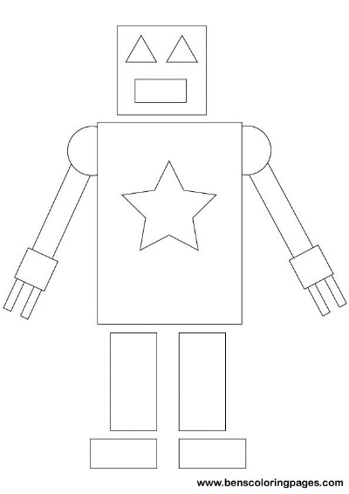  You need to write a description of the guilty robot using your knowledge of the features of 2D shapes e.g. angle sum of triangles and quadrilaterals, parallel lines, opposite sides and angles etc. (Google docs or maths books) | Maths  Problem solving  - Maths Mate  (Google Classroom)  - 10 problems (Google Classroom)  Understanding Maths
1.10 – Lunch Break
1.55 | Science  Fill a bowl halfway with water and add a few sprinkles of pepper.  Fill a second bowl halfway with water and a drop of soap.  Now, dip your finger into the dish with pepper water. Look at your finger. It may have a few specks of pepper on it.  Dip your finger in the dish with soap water, making sure it’s fully submerged.  Now dip your soap-covered finger back into the dish of pepper water. You should see the pepper immediately move away from your finger.  Record your observations and explain how this is important in the current world situation. | PE  Balancing:  - Stand on one foot and lift the other leg whilst bending your knee. Place your leg back on the ground.  - Repeat but this time, after lifting your leg, straighten your leg out in front of your body.  - Repeat 1 and 2 with the other leg.  - Repeat all of the above 4 more times.  Walking in a line:  ~Walk a straight line, moving one foot in front of each other, so that your toes touch the heel of the front foot. Keep walking until you have walked approximately 3 metres  ~Now try going backwards 3 metres!  Try any or all of the above with your eyes shut. | Visual Art  Choose any object in your house. Sketch it from at least 2 different perspectives. (On a piece of paper or in your book) | History  Research one of the following Australian explorers:  Burke and Wills  Sir Charles Kingsford Smith  Matthew Flinders  Sir Douglas Mawson  Charles Sturt  Jessica Watson  Write a short report on their achievements and legacy.  You can search the internet, books that you have at home or ask someone at home who may have some knowledge about this. You could also look up TV shows, especially if you have Foxtel etc.  (Google docs folder) | Catch-up  Complete or revise any tasks from the week.

